**CS 335**

**Web Development**

Fall 2023/2024

**Milestone 2**

**Project Design, Technology Stack, and User Stories**

**TEAM Members**

NAME, ID

NAME, ID

**Project Title:**

[name of your web application]

## Wireframe Design

[A wireframe is a basic, visual representation of the layout and functionality of a web app or website. Think of it as the skeleton or blueprint of your design; it shows where elements will be located and how they will function, without focusing on detailed design.]

**[Layout, Navigation, Content, Interaction]**

[Example: Blog - single post]

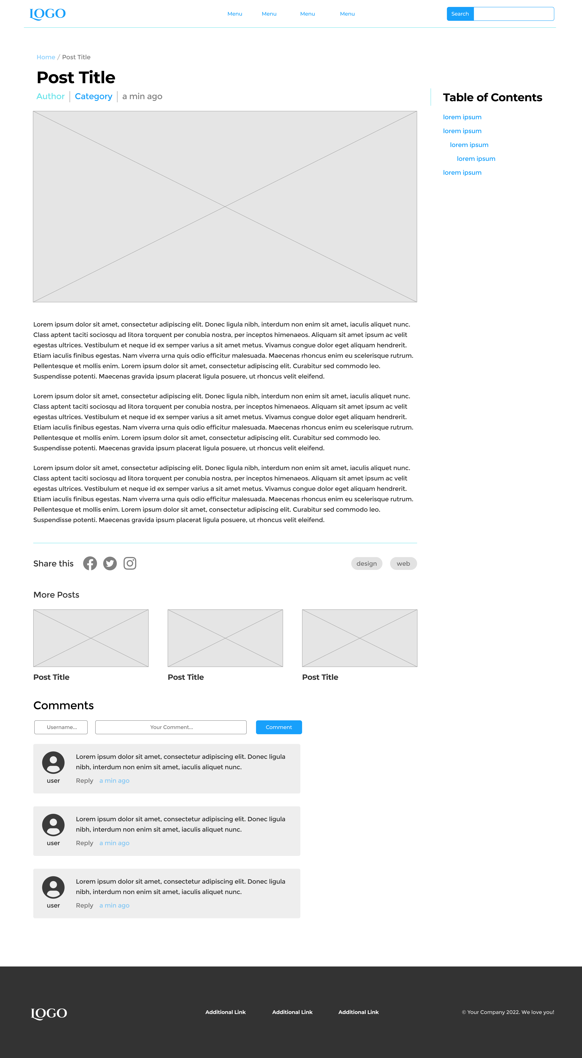

## User story scenarios

* + - 1. **Use Case # 1:** [searching for a book]

|  |  |
| --- | --- |
| **As a** | [registered user] |
| **I want** | [to search for a book by title, author, or ISBN] |
| **So that** | [I can quickly find and purchase the book] |

**Acceptance Criteria:**

1. When I enter the title or part of the title in the search bar, a list of matching books should be displayed.
2. The list should show relevant details such as the book cover, author, price, and availability.
3. If no matches are found, the system should provide a message indicating that there are no results.
4. The search should be case-insensitive and should handle minor typos or variations in spelling.
5. The system should offer filtering options based on genre, author, and price.
   * + 1. **Use Case # 2:** [Creating a New User Account]

|  |  |
| --- | --- |
| **As a** | [new user] |
| **I want** | [sign up for an account on the bookstore's website] |
| **So that** | [I can track my orders, save favourite books, and receive personalized recommendations] |

**Acceptance Criteria:**

1. When I click on the 'Sign Up' button, I should be directed to a registration form.
2. The registration form should require fields such as name, email, password, and a password confirmation.
3. The system should check for password strength and provide feedback (e.g., minimum length, a mix of characters, etc.).
4. After submitting the form, I should receive a confirmation email to verify my email address.
5. Upon successful registration, I should be automatically logged into my new account and redirected to the homepage with a welcome message.
6. The system should provide error messages for any incomplete or incorrect information.
7. There should be an option to see the password while typing to ensure accuracy.
   * + 1. **Use Case ###:** [Forgot Password], [Login with social media], [Edit Profile Details]